Behaviours

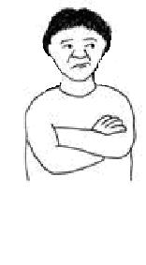
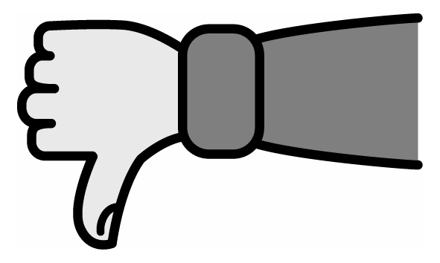

I sometimes swear and bite,
and show unsociable behaviour.

This needs to be discouraged.

Here are some phrases which will help discourage these behaviours:

“Don’t be silly Mike”

“Please don’t do that”

