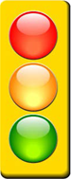
If you need to come into hospital, please bring this sheet with you, along with your hospital passport.
COVID-19 Learning Disability 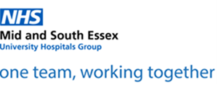
Hospital Summary

 | Name |  |  |  |  | Address
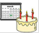 | Date Of Birth
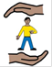 | Keeping me safe (any risks or behaviours that hospital staff need to know)
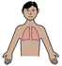 | Breathing issues  (e.g. asthma, history of respiratory infections) |  | 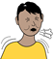 | If I have a new cough, when did it start? |  |  |  | If I have a temperature when did it start?
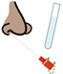 |  | What support would I need to have a swab taken? |  | Have I had any change in skin colour? |  |  |  | Have I had contact with a person with a new cough or fever?
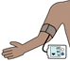 |  | Physical observations (what support would I need to have my blood pressure and temperature checked)

 | Someone who knows me well (this should be someone that we can talk to about your care and treatment) |  | Things that I like or would distract me if I am upset
Name:

Relationship:

Telephone number:
The most common symptoms of coronavirus (COVID-19) are:

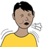 | a new, continuous cough
 | a high temperature (37.8 degrees and above)

If you have symptoms of coronavirus and need medical advice, 111
Do not go to places like a GP surgery,
pharmacy or hospital

Use the NHS 111 coronavirus service.

