

This is my

**Hospital Passport**

**This booklet will help you support me in an unfamiliar place**

**My name is**

If I have to go to hospital this book needs to go with me, it gives hospital staff important information about me.

**This booklet can support you to make a reasonable adjustment for me.**

**This passport belongs to me. Please update and return it when I am discharged.**

## Things you must know about me

**Things that are important to me**

**My likes and dislikes**

**Please be aware of any advanced decision, LPA, Court Protection.**



**Mental Capacity Act 2005 - applicable to people aged 16 and over**

If a person is assessed as lacking the ability to make a decision and needing an advocate, please follow local Mental Health Capacity Act Policies and Mental Capacity Act Code of Practice 2005.

If I am assessed as lacking the capacity to consent to my treatment, the following people must be involved in any decisions made in my best interest.

|  |  |  |
| --- | --- | --- |
| **Name** | **Relationship** | **Contact details** |
|  |  |  |
|  |  |  |

# Things you **must** know about



Name:

Likes to be known as:

NHS number: Date of birth:



Address:

Telephone number:

Family contact person:

Relationship-e.g. mum, dad:

Address:

Telephone number:



Allergies, adverse drug reactions or intolerance:



GP:

Address:

Telephone number:

Other services/professionals involved with me - e.g. social workers, advocate, named carer, etc.



How I communicate and how to communicate with me:



What language I speak:

Sight/hearing (problems with seeing or hearing):

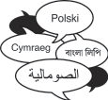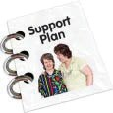

My support needs and who gives me the most support:

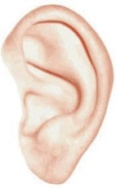

How I take medication (whole tablets, crushed tablets, injections, syrup). Please refer to my most recent prescription:

Medical interventions - how to take my blood, give injections, blood pressure, etc.

Heart/breathing problems:

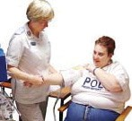

Risk of choking, dysphagia (eating, drinking and swallowing):

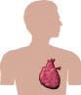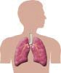





My medical history and current diagnosis:

What makes me anxious or afraid, how I may react (risk to me and others, triggers, do I have a behaviour management plan?) How you can support me:

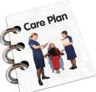

**As the relative and/or carer of: I can:**

Visit out of normal visiting hours.

Provide assistance in washing and dressing. Provide assistance in feeding.

Be actively involved in team meeting discussions, and planning the discharge where appropriate, about the person I care for.

Provide support to the person I care for, when having investigations in the hospital Other: (please describe)

I will inform staff if I am entering or leaving the ward outside of normal visiting hours. I understand that, at times, I may be asked to leave the ward or bay if there is a clinical necessity

I agree that if I am assisting with feeding, washing or mobilising, that staff may work alongside me to fulfil their clinical responsibility.

**During your relatives / cared for stay at the hospital you will have access to:**

* Regular liquid refreshment
* Flexible visiting hours

**Name: Relative Carer: Signature:**

**Authorised by: Designation: Date: Review date:**

Things that are **important** to me

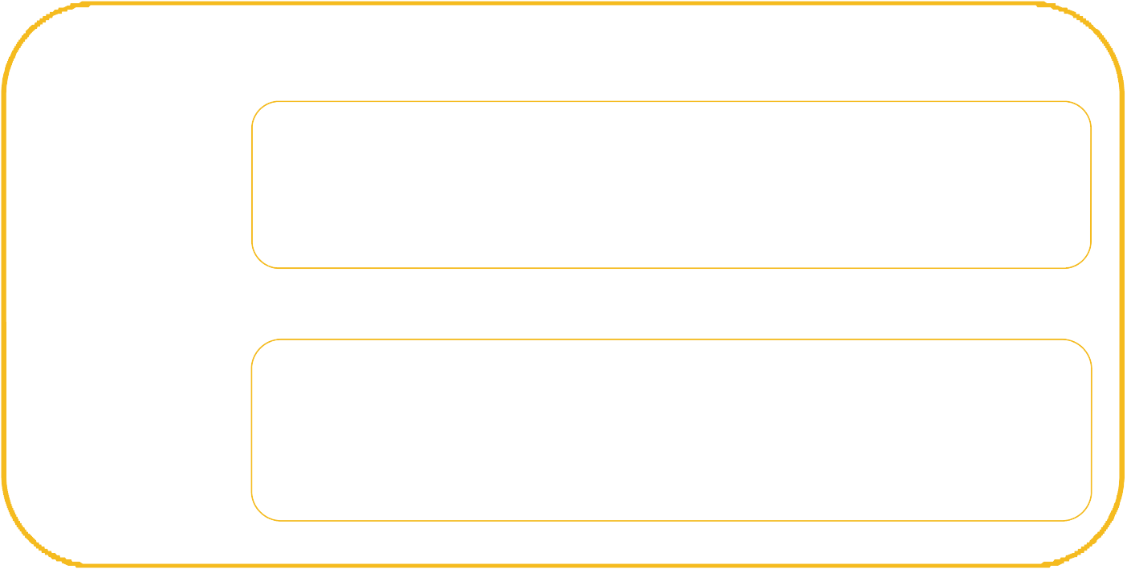

My sensory reactions (under sensitive, over sensitive to light, noise, touch, smell, taste):

How you know I am in pain:

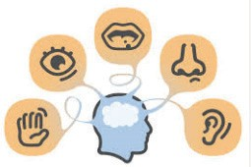

Moving around (posture in bed, walking aids):

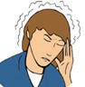

Personal care (dressing, washing etc.):

Things that are **important** to me



How I eat (food cut up, pureed, risk of choking, help with eating):

How I drink (drink small amounts, thickened fluids):

How I keep safe (bed rails, risk of falls, wandering, can I call for help):

How I use the toilet (continence aids, help to get to the toilet):



Sleeping (sleep pattern/routine):

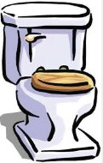

Religion and religious/spiritual needs:

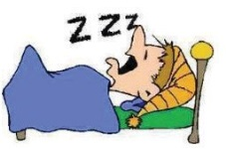

## Likes:

For example-what makes me happy, things I like to do such as watching TV, reading, music, routines that are important to me.

## Dislikes:

For example-don't shout, food I don't like, physical touch, things that worry or upset me.

## Things I like

Please do this:

**Things I don't like**

Don't do this:



Current and past interests, jobs and places I have lived in. My life so far (family, home, background, treasured possessions)



### Advocacy:

Advocacy is taking action to help people:

* + Express views and wishes
  + Secure their rights
  + Have their interests represented
  + Access information and services and
  + Explore choice and options

People who experience difficulties in communication have a right to be represented in decisions about their lives.

If a person is assessed as lacking the ability to make a decision and needing an advocate, please follow local Mental Capacity Act Policies and Mental Capacity Act Code of Practice 2005.

### Useful contacts/websites:



Essex Safeguards Unit 01245 434861

Southend Safeguarding 01702 215008

Age Concern 01279 541930

Help the Aged [www.helptheaged.org.uk](http://www.helptheaged.org.uk/)

Mental Capacity Act [www.gov.uk/government/publication/mental-](http://www.gov.uk/government/publication/mental-) capacity-act-code-of-practice



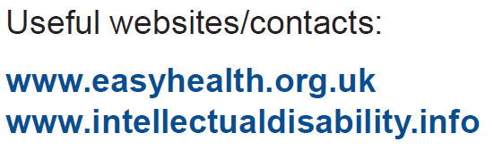

### Further information on the Hospital Passport is available from:

Clinical Nurse Specialist-Learning Disabilities Tel: 01702 435555 ext. 6448

This passport has been developed within Basildon and Thurrock Hospitals NHS Foundation Trust and Southend University Hospital NHS Foundation Trust, but please feel free to use it for patients in other Boroughs. The contact details for local Community Learning Disability Service are:

**The Health Facilitation Service 01268 739134**

# Information for patients

Tel: 01702 385333

Email: [pals@southend.nhs.uk](mailto:pals@southend.nhs.uk) Web: [www.southend.nhs.uk](http://www.southend.nhs.uk/)

This Hospital Passport was developed by Basildon and Thurrock University Hospital NHS Foundation Trust and Southend University Trust (January 2014) and is based on original work by St George’s Healthcare NHS Trust.